Internet Softverske Arhitekture



***ShooStore***

Lazar Smiljkovic 2017201826 SII

**About ShooStore:**

**ShooStore** is a web application used for discussion about shoes, adding new shoes to discussion and everything connected to shoes. In the future this site should have a store implemented.

**Database:**

|  |  |  |  |  |
| --- | --- | --- | --- | --- |
| User | Group | Comment | Shoe_comment | Shoe |
| user_id | group_id | comment_id | shoe_comment_id | shoe_id |
| email | name | text | shoe_id | name |
| username |  | user_id | comment_id | rating |
| password |  | date_posted | user_id | Image_url |
| token |  | password |  |  |
| group_id |  | commented_by |  |  |
| Is_admin |  |  |  |  |

MySQL Database

**Pages of the site (React):**

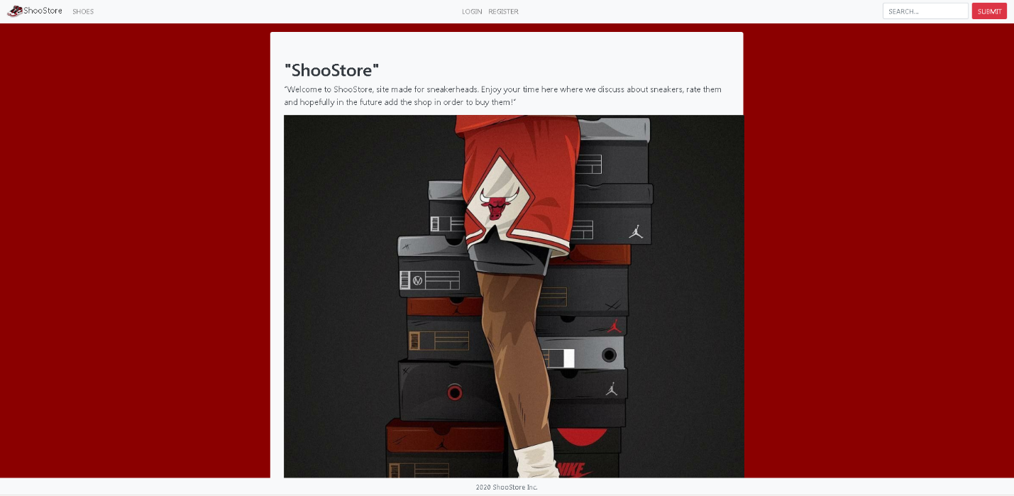

**Home page –** Users can register/login/search shoes and enter shoe list from this page.

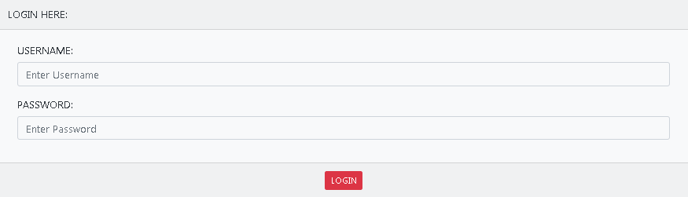

**Login -** User inputs registered data here, data is picked up from database and user is logged in, user can be logged in as admin/moderator/user depending on group rights.

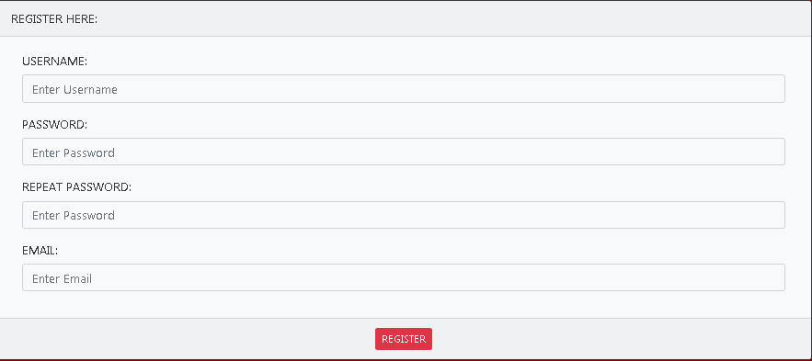

**Register –** User inputs basic data and is added to mysql database afterwards he can login.

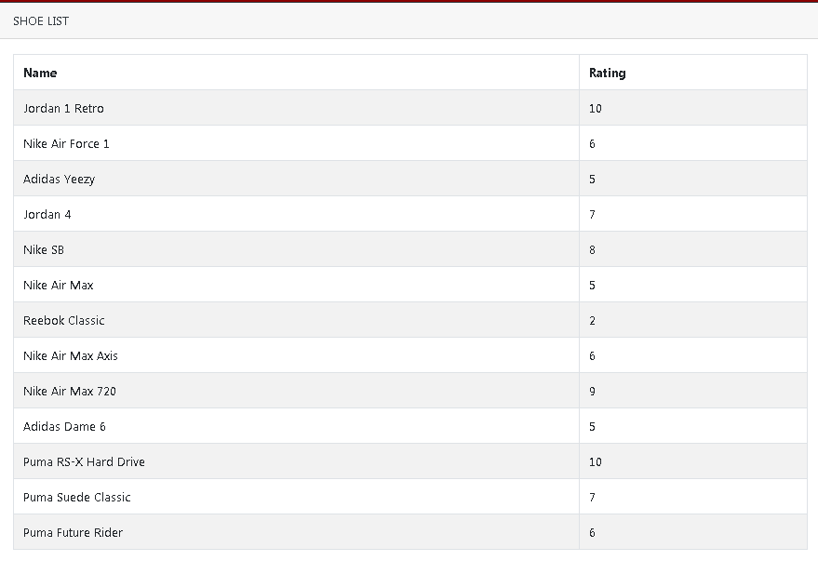

**Shoe List –** Users can access a shoe list where all shoes are showed and after clicking on particular shoe we get routed to Shoe Page. If logged in user is admin he can also delete/edit the shoes

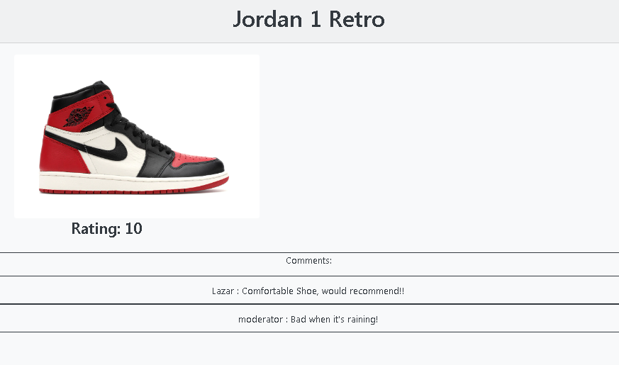

**Shoe Page** – Here we have a better description of a shoe and its picture aswell as rating and comments.

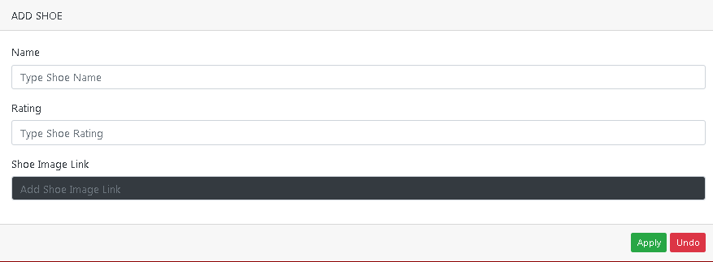

**Add Shoe –** Admin can add the shoe by writing its name/rating/image link.

**Project Structure:**

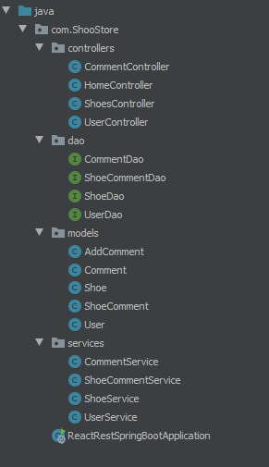

**How the project looks**

**DAOs:**

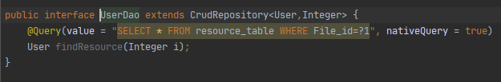

**UserDao**

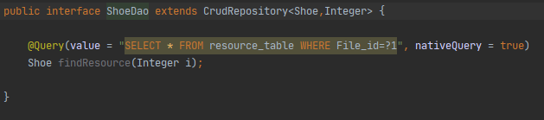

**ShoeDao**

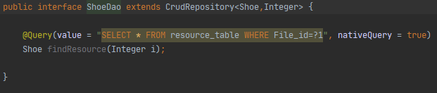

**ShoeCommentDao**

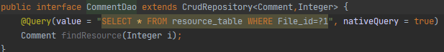

**CommentDao**

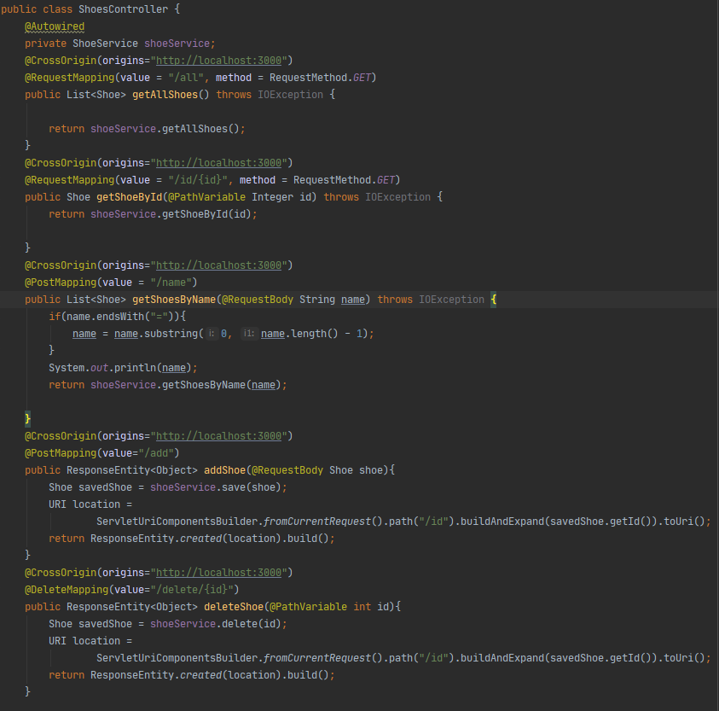

**ShoesConttroller**

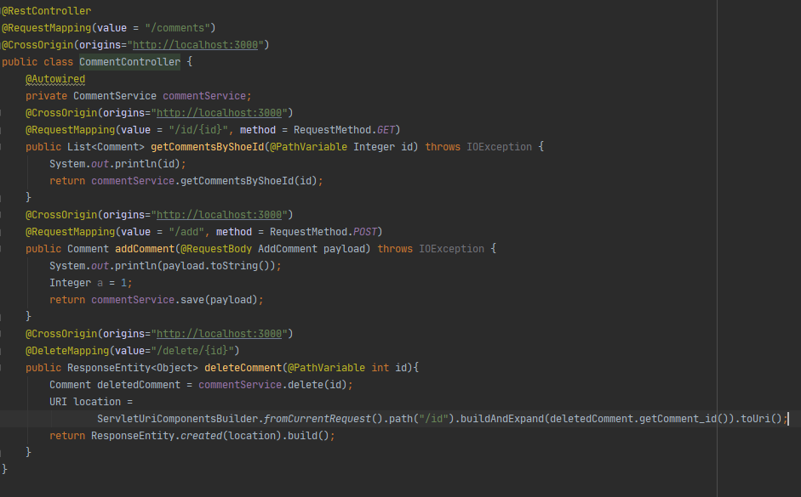

**CommentController**

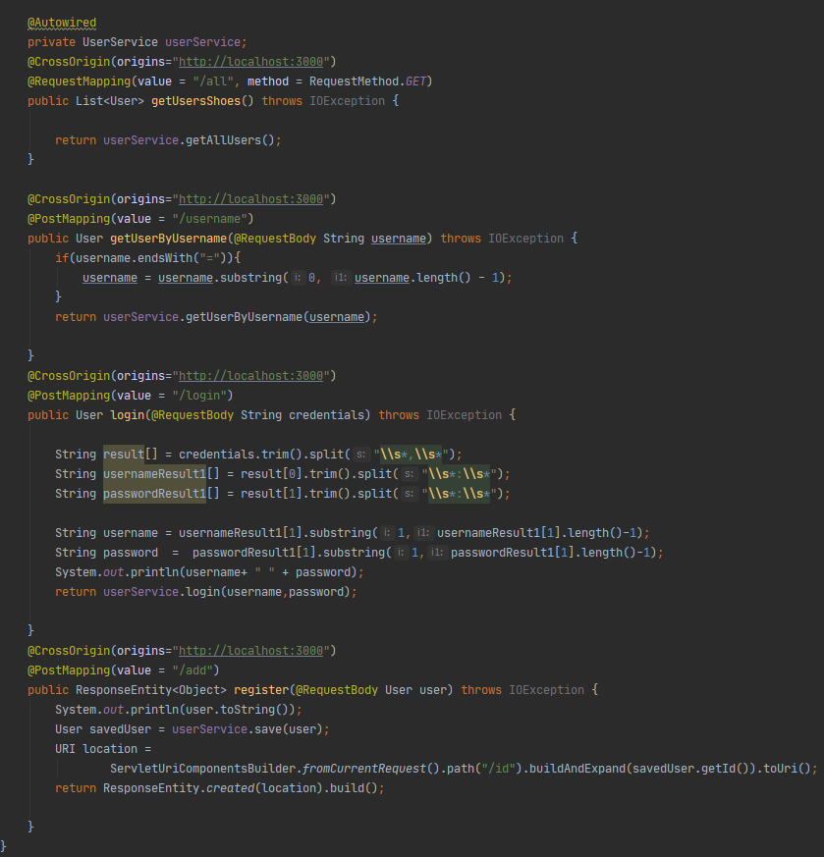

**UserController**

**POST Requests:**

***POST***: <http://localhost:8082/comments/add> - Add new comment

***POST***: <http://localhost:8082/users/username> - Retrieve user by username

***POST***: <http://localhost:8082/users/login> - Login

***POST***: <http://localhost:8082/users/add> - Add new user

***POST***: <http://localhost:8082/shoes/name> - Retrieve shoe by its name

***POST***:<http://localhost:8082/shoes/add> - Add new shoe

**GET Requests:**

***GET*** [http://localhost:8082/comments/id/{id}](http://localhost:8082/comments/id/%7bid%7d) - Retrieve a comment by ID

***GET*** <http://localhost:8082/users/all> - Retrieve all users

***GET*** <http://localhost:8082/shoes/all> - Retrieve all shoes

***GET*** [http://localhost:8082/shoes/id/{id}](http://localhost:8082/shoes/id/%7bid%7d) - Retrieve a shoe by it’s id